# Consideration Items

Gilded Rose Document

Iversoft Dev Test Explanation

Zoltan Jakab

2020

**How do we know if a user is authenticated?**

Asp Net Core largely handles this with authentication annotations. In our case, we want to ensure two things in a production environment. First, **the** **email of the user should be confirmed.** This ensures its not a bot. Second, **we write checks in our service layer to ensure a valid user id is given to us.**

**Is it always possible to buy an item?**

No. Sometimes, items will go out of stock. The application reflects this by preventing the user from buying an item.

# Explanations

**Application Architecture**

Generally, our application relies on a hidden service layer that handles all our transactions and business logic. Our existing services are the **ProductService** which handles product querying and retrieval, and the **ProductTransactionService** which handles the user purchasing a product.

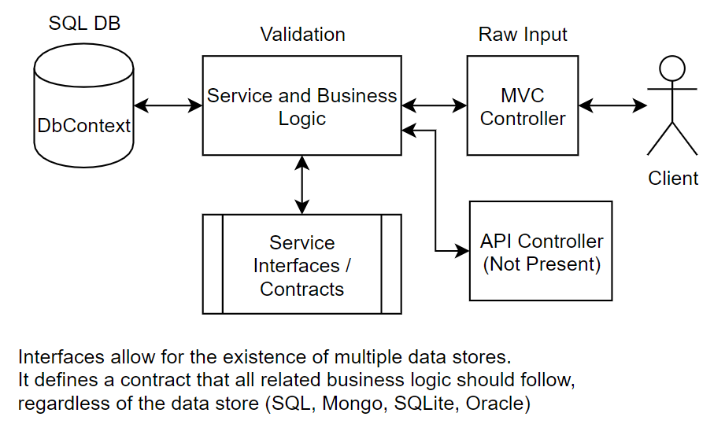

**Shortcuts Taken**

The initial design included the usage of VueJS for the front end. The scale of the application allowed for it, and it would have made some components easier. However, since the app itself was a simple proof of concept, the usage of basic jQuery and AJAX calls were used in combination with Partial Views and templates to achieve the same desired effect with less work.

Other shortcuts included the scaffolding and usage of Identity (authentication), using Entity Framework Core to generate a code first database with migrations, using Bootstrap 4.0 (CSS) for desired stylings. The reasoning behind this was “there is no need to reinvent the wheel. If it works out of the box, use it.”

**Which Authentication Mechanism was used and why?**

Identity was used, as it is software that comes scaffolded with ASP.NET Core. It is flexible and a lot of the provided views and interfaces it provides are flexible and simple to understand. It is also relatively secure.

For additional security, in a production application, we would only allow product purchasing if the user’s email were authenticated. Even further, if they store payment information on the application itself, we may consider enforcing 2-factor authentication for added security.